Localization Guide

Contents

1 Summary 2
1.1 Goals 2
1.2 Overview 2
2 Pre-requisitions 3
2.1 Microsoft Windows SharePoint Services 3.0 3
2.2 Source Code from CodePlex 3
2.3 SLK Install Package 3
2.4 Visual Studio Team System 3
3 Creating a New Language Pack 3
3.1 Introduction 3
3.2 To create a language pack: 3
4 Deploying a Test Language Pack 4
4.1 To deploy the Test Language Pack 4
5 Testing Translated Version 5
6 Submitting Translated Translation XML files to CodePlex 5
7 Appendix 6
7.1 References 6
7.1.1 Globalization: Step-by-step 6
7.1.2 Understanding Internationalization 6
7.1.3 Testing for World-Readiness 6
7.1.4 Localization Testing 6
7.1.5 Microsoft .NET Internationalization 6
7.1.6 Introduction to Code Signing 6
7.1.7 List of Locale ID (LCID) Values as Assigned by Microsoft 6
7.2 Translation File Sample 6

Summary
This guide outlines the procedure to follow to produce a Language Pack for the SLK.

Goals
The goal of this project and this guide is to provide instructions and tools to produce a Language Pack for the SLK.

Overview
The illustration below outlines the process.
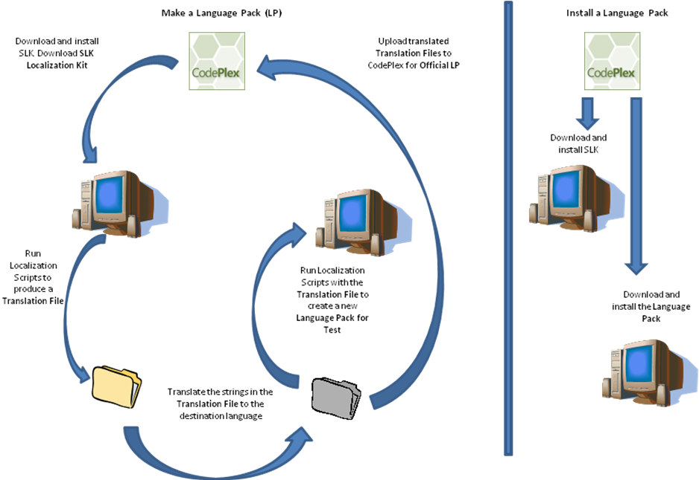
The tools in Localization Guide will allow you to extract all the text strings from the SLK product into XML files, these are known as the Translation Files.
The Translation files can then be translated by a translator.
The tools in Localization Guide will allow you to build a test Language Pack with the translated Translation Files. You should test this test Language Pack in a test environment only.
Once satisfied that the translations are correct and appropriate, the translated Translation Files can be uploaded to CodePlex. Once on CodePlex, the SLK Community Lead will create a Microsoft security code signed Language Pack and make it available on CodePlex.

Pre-requisitions

Microsoft Windows SharePoint Services 3.0
You must have Windows SharePoint Services 3.0 installed. WSS is available from: http://www.microsoft.com/technet/windowsserver/sharepoint/download.mspx

Source Code from CodePlex
Visit the SLK site on CodePlex [www.codeplex.com/slk] to register and get the latest code for the SLK.

SLK Install Package
Install the SLK as per instructions provided with the SLK.

Visual Studio Team System
Required for Developer access to the CodePlex source tree.

Creating a New Language Pack

Introduction
A new SLK Language Pack (LP) can be created by following the steps below.
NOTE: For security reasons, Language Packs generated in this way should only be used in a test environment as they will be marked for to be skipped by the security verification process. Language Packs marked in this way should NOT be deployed in a production environment.
The word count for the total SLK v1.0 product is approx 780 text strings (approx 21,000 words). This set of strings includes a lot of error messages which, in general use, would not appear to the end user. The crucialStrings.txt file in the etc folder contains all the StringIDs of the common errors, user strings and admin strings. The crucialStrings.txt file contains approx 300 text strings (approx 2,500 words). If you choose, you can translate only these strings to reduce the resources required to create a new Language Pack.

To create a language pack:
- Extract the files in the Localization Guide ZIP file.
- Copy the following assemblies from the SLK installation point to the “Release” folder. These DLLs can also be obtained from the SLK SDK which is also available for download on CodePlex:
  - Microsoft.SharePointLearningKit.dll
  - Microsoft.LearningComponents.SharePoint.dll
  - Microsoft.LearningComponents.Storage.dll
  - Microsoft.LearningComponents.dll
  - (they can also be found inside the SLK CAB file SharePointLearningKit.wsp, which can be opened with WinZip)
- Run ExtractStrings.cmd from the command line in the “Release” folder. This will generate the .xml files which can be localized.

- Localize the <Translation> elements in the .xml files and edit the “culture” attribute at the top of each file to reflect the culture of the localized language. Note: only global cultures should be used (e.g. fr instead of fr-FR).
Additionally there are a few strings in SlkSettings.xml.dat which need translating (the attributes “Title”, “NullDisplayString” and “ToolTipFormat”).
A sample subset of a Translation file is in the Appendix.

- In the etc folder are two text files with string ID’s: dontlocalize.txt and crucialStrings.txt:
  - dontLocalize.txt contains the ID’s of strings which should not be localized as they can break SLK functionality.
  - crucialStrings.txt contains a list of the ID’s of the most common UI elements: in some cases it might be sufficient to get just these strings translated (plus the ones in slkSettings.xml.dat). Most of the UI will be localized, most error message will still be in English.
- Copy the localized .xml files into a folder with as name the language LCID (e.g. 1033 for US English) in the TranslatedXMLs folder
- Run ”GenerateLanguagePack.cmd <LCID> Release” from the command line in the “TranslatedXMLs” folder. This will use the localized .xml files to generate the satellite assemblies with the localized resources and then build the .wsp file using those files.
The language pack (contents of the folder “Solution\LanguagePacks\<LCID>”) is now ready to be deployed.

Deploying a Test Language Pack

To deploy the Test Language Pack

- Use sn.exe –Vr on all satellite assemblies (*.resources.dll files which can be found in the “bin” folder after creating a language pack) on the machine you want to deploy the Language packs on, if the satellite assemblies were not codesigned.
NOTE: This will mark all the Language Pack satellite assemblies to be skipped during the security verification process. This should only be done in a test environment.
- Run AddSolution.cmd from the LanguagePacks\<LCID> folder.
- Run DeploySolution.cmd from the LanguagePacks\<LCID> folder.
- Verify using EnumSolutions.cmd that the language pack has been deployed correctly.
- In Sharepoint set the Locale to the correct value (the one corresponding to the culture of the localized resources) in Site Settings/Site Administration/Regional Settings.

You can use RetractSolution.cmd and DeleteSolution.cmd to remove the language pack.

Testing Translated Version
Refer to the documentation referenced in the Appendix - Localization Testing.
Localization testing should focus on several general areas. The first involves things that are often altered during localization, such as the UI and content files. The second consists of culture-specific, language-specific, and country-specific areas. Examples include configurable components-such as region defaults and the default language-as well as language-specific and region-specific functionality-such as default spelling checkers, speech engines, and so on. You should also test the availability of drivers for local hardware and look for the encryption algorithms incorporated into the application. The rules and regulations for distribution of cryptographic software differ from country to country.
In particular, localization testing of the UI and linguistics should cover items such as:
• Validation of all application resources.
• Verification of linguistic accuracy and resource attributes.
• Checking for typographical errors.
• Checking that printed documentation, online Help, messages, interface resources, and command-key sequences are consistent with each other. If you have shipped localized versions of your product before, make sure that the translation is consistent with the earlier released versions.
• Confirmation of adherence to system, input, and display environment standards.
• Checking usability of the UI.
• Assessment of cultural appropriateness.
• Checking for politically sensitive content.
• Making sure the market-specific information about your company, such as contact information or local product-support phone numbers, is updated.

Submitting Translated Translation XML files to CodePlex
Once testing has completed on the Test Language Pack, the translated Translation XML files can be uploaded to CodePlex where, when internally built through the internal build process, will generate a Microsoft codesigned Language Pack
Developer access to the SLK CodePlex site will be required to upload the translated Translation XML files.
The process to upload these translation files to CodePlex is same as any other check-in into the SLK source code tree. Details can be found on www.codeplex.com/slk
Translated Translation Files should be uploaded to the SLK code tree on CodePlex under SLK/SLK/Tools/LocalizationGuide/TranslatedXMLs into a directory created for the language.

Appendix

References

Globalization: Step-by-step
http://www.microsoft.com/globaldev/getwr/steps/localization/loc_est_loc_gls.mspx

Understanding Internationalization
http://www.microsoft.com/globaldev/getwr/steps/wrg_g11n.mspx

Testing for World-Readiness
http://www.microsoft.com/globaldev/handson/dev/wrtesting.mspx

Localization Testing
http://www.microsoft.com/globaldev/getWR/steps/testing/test_l10n_test.mspx

Microsoft .NET Internationalization
http://www.microsoft.com/globaldev/getwr/dotneti18n.mspx

Introduction to Code Signing
http://msdn2.microsoft.com/en-us/library/aa380259.aspx

List of Locale ID (LCID) Values as Assigned by Microsoft
http://www.microsoft.com/globaldev/reference/lcid-all.mspx

Translation File Sample
<root>
<resources>
<NewDataSet>
<Resources>
<ID>FRM_LearnerReviewNotAvailableMsgHtml</ID>
<Source>You cannot review this assignment until it is returned by your instructor.</Source>
<Translation>You cannot review this assignment until it is returned by your instructor.</Translation>
</Resources>
<Resources>
<ID>FRM_Title</ID>
<Source>SharePoint Learning Kit Training</Source>
<Translation>SharePoint Learning Kit Training</Translation>
</Resources>
<Resources>
<ID>GradingReturnMessage</ID>
<Source>All learner assignments will be returned to the learners. If you have not graded all the assignments, some learners may receive zero points.</Source>
<Translation>All learner assignments will be returned to the learners. If you have not graded all the assignments, some learners may receive zero points.</Translation>
</Resources>
</NewDataSet>
</resources>
</root>

If you forget to do this before deployment, deployment will fail and the wssadmin.exe service will need to be restarted before retrying

